Global-tech incorporation is leading Biotech & Medical distribution company, has decided to migrate their data warehouse (around volume of 300TB uncompressed) to Cloud. Also, this organization has decided to migrate all downstream applications to Azure. Since its COVID – pandemic situation, hence its critical time & ETA is very less, the whole migration had to happen seamlessly, Using Azure cloud Service – we have to develop solutions for Global-tech. and migration activity to be performed.

**CASE 1:**

**STEP 1:**

CREATE TABLE globetechtb231 (emp_id INTEGER NOT NULL, emp_name VARCHAR2(15) NOT NULL, job_name VARCHAR2(10) NOT NULL, manager_id INTEGER, hire_date DATE NOT NULL, salary DECIMAL(10,2) NOT NULL, commission DECIMAL(7,2), dep_id INTEGER NOT NULL);

**STEP 2:**

INSERT INTO globetechtb231 (emp_id , emp_name ,job_name , manager_id, hire_date , salary , commission , dep_id)

values (68319 , 'KAYLING' ,' PRESIDENT' , NULL , DATE'1991-11-18', 6000.00 , NULL , 1001);

INSERT INTO globetechtb231 (emp_id , emp_name ,job_name , manager_id, hire_date , salary , commission , dep_id)

values (66928 , 'BLAZE' , 'MANAGER' , 68319 , DATE'1991-05-01' , 2750.00 ,NULL , 3001);

INSERT INTO globetechtb231 (emp_id , emp_name ,job_name , manager_id, hire_date , salary , commission , dep_id)

values (67832 , 'CLARE' , 'MANAGER ' , 68319 ,DATE'1991-06-09' , 2550.00 ,NULL, 1001);

INSERT INTO globetechtb231 (emp_id , emp_name ,job_name , manager_id, hire_date , salary , commission , dep_id)

values (65646, 'JONAS' , 'MANAGER' , 68319 , DATE'1991-04-02' , 2957.00 ,NULL ,2001 );

INSERT INTO globetechtb231 (emp_id , emp_name ,job_name , manager_id, hire_date , salary , commission , dep_id)

values (67858, ' SCARLET', 'ANALYST' , 65646 , DATE'1997-04-19' , 3100.00 ,NULL , 2001);

INSERT INTO globetechtb231 (emp_id , emp_name ,job_name , manager_id, hire_date , salary , commission , dep_id)

values (69062 , 'FRANK' , 'ANALYST' , 65646 , DATE'1991-12-03' , 3100.00 ,NULL ,2001);

INSERT INTO globetechtb231 (emp_id , emp_name ,job_name , manager_id, hire_date , salary , commission , dep_id)

values (63679 ,'SANDRINE' , 'CLERK' , 69062 , DATE'1990-12-18' , 900.00 ,NULL, 2001 );

INSERT INTO globetechtb231 (emp_id , emp_name ,job_name , manager_id, hire_date , salary , commission , dep_id)

values (64989 , 'ADELYN' , 'SALESMAN' , 66928 , DATE'1991-02-20' , 1700.00 , 400.00 , 3001);

INSERT INTO globetechtb231 (emp_id , emp_name ,job_name , manager_id, hire_date , salary , commission , dep_id)

values (65271 , 'WADE' , 'SALESMAN' , 66928 , DATE'1991-02-22' , 1350.00 , 600.00 , 3001);

INSERT INTO globetechtb231 (emp_id , emp_name ,job_name , manager_id, hire_date , salary , commission , dep_id)

values (66564 , 'MADDEN' , 'SALESMAN', 66928 , DATE'1991-09-28' , 1350.00 , 1500.00 , 3001);

INSERT INTO globetechtb231 (emp_id , emp_name ,job_name , manager_id, hire_date , salary , commission , dep_id)

values (68454 , 'TUCKER' , 'SALESMAN' , 66928 , DATE'1991-09-08' , 1600.00 , 0.00 , 3001);

INSERT INTO globetechtb231 (emp_id , emp_name ,job_name , manager_id, hire_date , salary , commission , dep_id)

values (68736 , 'ADNRES' , 'CLERK' , 67858, DATE'1997-05-23' , 1200.00 , NULL , 2001);

INSERT INTO globetechtb231 (emp_id , emp_name ,job_name , manager_id, hire_date , salary , commission , dep_id)

values (69000 , ' JULIUS' , 'CLERK' , 66928 , DATE'1991-12-03' , 1050.00 , NULL , 3001 );

INSERT INTO globetechtb231 (emp_id , emp_name ,job_name , manager_id, hire_date , salary , commission , dep_id)

values (69324 ,' MARKER' , 'CLERK' , 67832,DATE'1992-01-23',1400.00, NULL, 1001 );

**STEP 3:**

* SELECT *

FROM globetechtb231;

**CASE 2:** SELECT salary

FROM globetechtb231;

|  |
| --- |
| **SALARY** |
| 6000 |
| 2750 |
| 2550 |
| 2957 |
| 3100 |
| 3100 |
| 900 |
| 1700 |
| 1350 |
| 1350 |
| 1600 |
| 1200 |
| 1050 |
| 1400 |
| 6000 |
| 2750 |
| 2550 |
| 2957 |
| 3100 |
| 3100 |
| 900 |
| 1700 |
| 1350 |
| 1350 |
| 1600 |
| 1200 |
| 1050 |
| 1400 |
| 2750 |
| 2550 |
| 2957 |
| 3100 |
| 3100 |
| 900 |
| 1700 |
| 1350 |
| 1350 |
| 1600 |
| 1200 |
| 1050 |
| 1400 |
| 6000 |
| 6000 |
| 2750 |
| 2550 |
| 2957 |
| 3100 |
| 3100 |
| 900 |
| 1700 |

**CASE 3:** SELECT DISTINCT job_name

FROM globetechtb231 ;

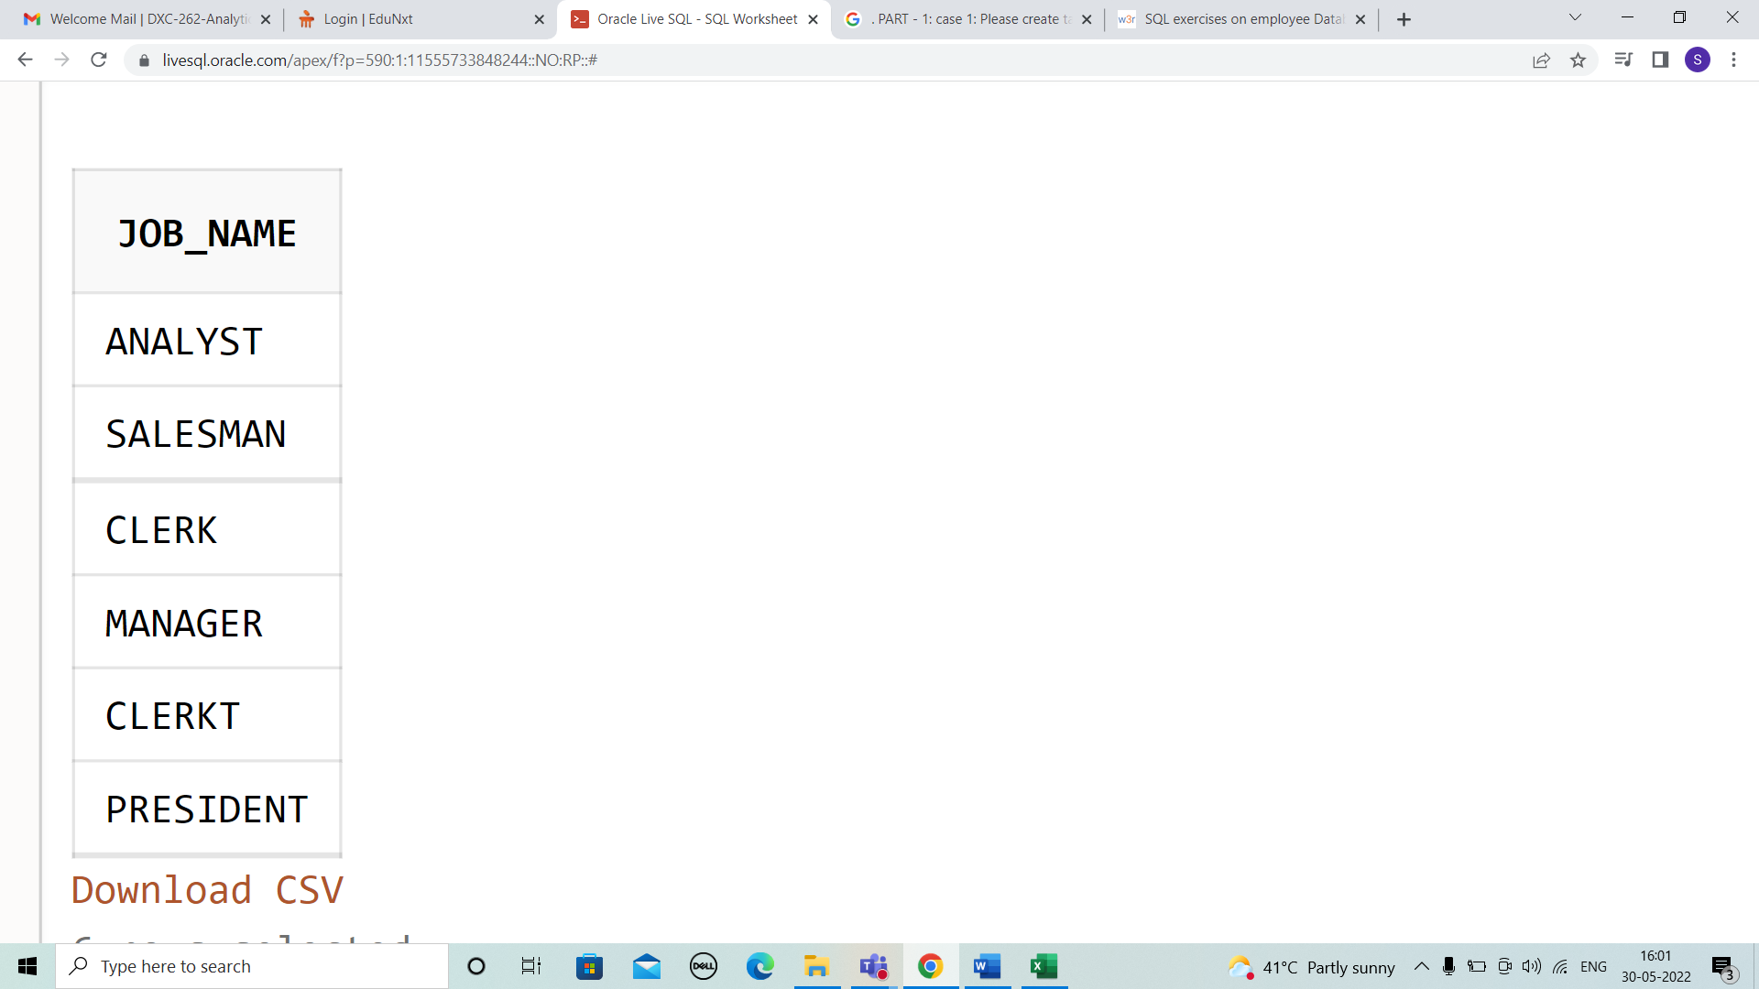

**CASE 4:** SELECT emp_name,

to_char(1.15*salary,'$99,999') AS "Salary"

FROM globetechtb231 ;

|  |  |
| --- | --- |
| **EMP_NAME** | **Salary** |
| KAYLING | $6,900 |
| BLAZE | $3,163 |
| CLARE | $2,933 |
| JONAS | $3,401 |
| SCARLET | $3,565 |
| FRANK | $3,565 |
| SANDRINE | $1,035 |
| ADELYN | $1,955 |
| WADE | $1,553 |
| MADDEN | $1,553 |
| TUCKER | $1,840 |
| ADNRES | $1,380 |
| JULIUS | $1,208 |
| MARKER | $1,610 |
| KAYLING | $6,900 |
| BLAZE | $3,163 |
| CLARE | $2,933 |
| JONAS | $3,401 |
| SCARLET | $3,565 |
| FRANK | $3,565 |
| SANDRINE | $1,035 |
| ADELYN | $1,955 |
| WADE | $1,553 |
| MADDEN | $1,553 |
| TUCKER | $1,840 |
| ADNRES | $1,380 |
| JULIUS | $1,208 |
| MARKER | $1,610 |
| BLAZE | $3,163 |
| CLARE | $2,933 |
| JONAS | $3,401 |
| SCARLET | $3,565 |
| FRANK | $3,565 |
| SANDRINE | $1,035 |
| ADELYN | $1,955 |
| WADE | $1,553 |
| MADDEN | $1,553 |
| TUCKER | $1,840 |
| ADNRES | $1,380 |
| JULIUS | $1,208 |
| MARKER | $1,610 |
| KAYLING | $6,900 |
| KAYLING | $6,900 |
| BLAZE | $3,163 |
| CLARE | $2,933 |
| JONAS | $3,401 |
| SCARLET | $3,565 |
| FRANK | $3,565 |
| SANDRINE | $1,035 |
| ADELYN | $1,955 |

**CASE 5:** SELECT emp_name|| ' ' ||job_name AS "Employee & Job"

FROM globetechtb231 ;

|  |
| --- |
| **Employee & Job** |
| KAYLING PRESIDENT |
| BLAZE MANAGER |
| CLARE MANAGER |
| JONAS MANAGER |
| SCARLET ANALYST |
| FRANK ANALYST |
| SANDRINE CLERKT |
| ADELYN SALESMAN |
| WADE SALESMAN |
| MADDEN SALESMAN |
| TUCKER SALESMAN |
| ADNRES CLERK |
| JULIUS CLERK |
| MARKER CLERK |
| KAYLING PRESIDENT |
| BLAZE MANAGER |
| CLARE MANAGER |
| JONAS MANAGER |
| SCARLET ANALYST |
| FRANK ANALYST |
| SANDRINE CLERKT |
| ADELYN SALESMAN |
| WADE SALESMAN |
| MADDEN SALESMAN |
| TUCKER SALESMAN |
| ADNRES CLERK |
| JULIUS CLERK |
| MARKER CLERK |
| BLAZE MANAGER |
| CLARE MANAGER |
| JONAS MANAGER |
| SCARLET ANALYST |
| FRANK ANALYST |
| SANDRINE CLERKT |
| ADELYN SALESMAN |
| WADE SALESMAN |
| MADDEN SALESMAN |
| TUCKER SALESMAN |
| ADNRES CLERK |
| JULIUS CLERK |
| MARKER CLERK |
| KAYLING PRESIDENT |
| KAYLING PRESIDENT |
| BLAZE MANAGER |
| CLARE MANAGER |
| JONAS MANAGER |
| SCARLET ANALYST |
| FRANK ANALYST |
| SANDRINE CLERKT |
| ADELYN SALESMAN |

**CASE 6:** SELECT emp_name || '('|| lower(job_name)||')' AS "Employee"

FROM globetechtb231 ;

|  |
| --- |
| **Employee** |
| KAYLING(president) |
| BLAZE(manager) |
| CLARE(manager) |
| JONAS(manager) |
| SCARLET(analyst) |
| FRANK(analyst) |
| SANDRINE(clerkt) |
| ADELYN(salesman) |
| WADE(salesman) |
| MADDEN(salesman) |
| TUCKER(salesman) |
| ADNRES(clerk) |
| JULIUS(clerk) |
| MARKER(clerk) |
| KAYLING(president) |
| BLAZE(manager) |
| CLARE(manager) |
| JONAS(manager) |
| SCARLET(analyst) |
| FRANK(analyst) |
| SANDRINE(clerkt) |
| ADELYN(salesman) |
| WADE(salesman) |
| MADDEN(salesman) |
| TUCKER(salesman) |
| ADNRES(clerk) |
| JULIUS(clerk) |
| MARKER(clerk) |
| BLAZE(manager) |
| CLARE(manager) |
| JONAS(manager) |
| SCARLET(analyst) |
| FRANK(analyst) |
| SANDRINE(clerkt) |
| ADELYN(salesman) |
| WADE(salesman) |
| MADDEN(salesman) |
| TUCKER(salesman) |
| ADNRES(clerk) |
| JULIUS(clerk) |
| MARKER(clerk) |
| KAYLING(president) |
| KAYLING(president) |
| BLAZE(manager) |
| CLARE(manager) |
| JONAS(manager) |
| SCARLET(analyst) |
| FRANK(analyst) |
| SANDRINE(clerkt) |
| ADELYN(salesman) |

**CASE 7:**

**CASE 8:** SELECT length(trim(emp_name))

FROM globetechtb231 ;

|  |
| --- |
| **LENGTH(TRIM(EMP_NAME))** |
| 7 |
| 5 |
| 5 |
| 5 |
| 7 |
| 5 |
| 8 |
| 6 |
| 4 |
| 6 |
| 6 |
| 6 |
| 6 |
| 6 |
| 7 |
| 5 |
| 5 |
| 5 |
| 7 |
| 5 |
| 8 |
| 6 |
| 4 |
| 6 |
| 6 |
| 6 |
| 6 |
| 6 |
| 5 |
| 5 |
| 5 |
| 7 |
| 5 |
| 8 |
| 6 |
| 4 |
| 6 |
| 6 |
| 6 |
| 6 |
| 6 |
| 7 |
| 7 |
| 5 |
| 5 |
| 5 |
| 7 |
| 5 |
| 8 |
| 6 |